
MACAU UNIVERSITY OF SCIENCE AND TECHNOLOGY

School of Computer Science and Engineering
Faculty of Innovation Engineering

CS460 D1 Computer Vision
Final Project Report

Topic: Research on Multi-frame Traffic Light Detection Based on Pseudo-label Self-learning

Student Names | Student No.
孙瑞阳 | 1220022641
曹嘉诚 | 1220022681
卢俊熹 | 1220000146

December, 2025

Abstract
In the current development of autonomous driving, ensuring models can efficiently recognize real-world traffic signals, such as traffic lights, is a crucial issue. While existing neural networks can accurately identify traffic light states, inclement weather and obstructions can still lead to misjudgments in the real world, and the cost of training data annotation is high.
To address this issue, the author proposed a Weakly-Supervised Multi-Frame Traffic Light Detection framework. This model integrates motion-guided temporal fusion, pseudo-label self-learning, and adverse-weather domain adaptation, enabling adaptive optimization and cross-weather generalization. Temporal stability refinement is also introduced to improve prediction consistency and stability.
Keywords: Self-learning; Autonomous driving; Multi-Frame; Domain adaptation; Adverse weather

Content
Abstract 1
1. Introduction 3
2. Objectives 4
3. Related work 5
3.1 Traffic light detection and recognition method 5
3.2 Video object detection and multi-frame fusion 5
3.3 Pseudo-Label Learning 6
3.4 Adverse Weather Perception and Domain Adaptation 6
4. Methodology 8
4.1 Overview 8
4.2 Motion-Guided Temporal Fusion 8
4.2.1 Motion Estimation 9
4.2.2 Feature Alignment 9
4.2.3 Motion Prior Constraints 9
4.2.4 Temporal Attention Fusion 11
4.3 Pseudo-Label Self-Learning 11
4.3.1 Trajectory construction based on cross-frame matching 11
4.3.2 Pseudo-label filtering 11
4.3.3 Time-series category consistency constraints 12
4.3.4 Confidence Reweighting 12
4.4 Temporal consistency refinement 12
4.5 Adverse Weather Adaptation 13
5. Preliminary experimental results 14
5.1Required hardware and software list 14
5.2 Data filtering 14
5.3 Videos editing 15
5.4 Experiment Results 16
References 18

1. Introduction
With the rapid development of autonomous driving technology, traffic light detection and recognition has become a crucial task in intelligent driving visual perception systems. As a core element of road traffic control, traffic lights directly impact vehicle traffic decisions and safety. Accurate and real-time identification of traffic light states (red, yellow, and green) is crucial for safe passage in complex urban environments.
However, traffic light detection faces numerous challenges in real-world scenarios due to environmental factors. In particular, in adverse weather conditions such as rain, fog, snow, nighttime, and backlighting, camera-captured images are prone to blurring, reduced contrast, and uneven illumination, significantly degrading the performance of object detection models. Furthermore, traffic lights are small in size, have limited pixels when photographed from a distance, and are easily obscured by trees or vehicles, further complicating detection and classification.
Currently, most traffic light detection methods rely on single-frame image recognition, ignoring the temporal correlation between consecutive video frames. These single-frame models are prone to transient misjudgments during real-world driving, such as flicker detection and unstable state transitions. Furthermore, data labeling for severe weather conditions is costly, and existing public datasets (such as LISA and BSTLD) mostly contain only sunny or mildly severe weather samples, making it difficult to support robust model training.
To reduce reliance on manual labeling and improve model adaptability to complex weather conditions, a self-learning, low-cost, and cross-domain robust detection method is urgently needed. This is the primary focus of this research. This study aims to develop a multi-frame video traffic light detection and state recognition framework suitable for complex weather environments. The research findings have potential applications in intelligent driving, traffic monitoring, assisted driving, and other fields, demonstrating excellent scalability and promising engineering applications.

2. Objectives
- Multi-frame feature fusion guided by motion priors to enhance temporal consistency;
- Weakly supervised pseudo-label self-learning mechanism to achieve model self-optimization based on a small amount of labeled data;
- Weather domain adaptation a to narrow the gap between sunny and severe weather domains;
- Temporally stable prediction module to enhance the consistency and reliability of light state predictions.

3. Related work

3.1 Traffic light detection and recognition method
Starting with the definition of the task, we need to clarify that traffic light recognition in the field of autonomous driving is actually divided into two core sub-tasks: locating the traffic light in the real world; and classifying the state of the traffic light at the tagged location (such as red, yellow, or green). In traditional solutions, matching based on color thresholds (such as HSV or RGB) and shape or geometric features can indeed accomplish this task, and it has the advantages of low computational cost and low implementation cost.[1] However, as this technology is tested and experimented with in reality, it has begun to show poor adaptability to the actual environment.[2] For example, occlusion by many obstacles will lead to failure to locate, and rainy or foggy weather will interfere with classification.
Currently, the most mainstream solution is single-frame detection based on deep learning. It is roughly divided into two methods: one is a one-stage detector and the other is a two-stage detector. The core idea of ​​the former is end-to-end, which directly performs dense prediction on the feature map. The advantage is that it is fast and can complete the detection in a single forward propagation. Moreover, the structure is simple, usually only one network is needed, and no candidate box generation is required. [3] For example, YOLO series [4] and SSD. The core idea of ​​the latter is to first generate candidate regions (Region Proposal), and then classify and refine the bounding boxes of the candidate regions. The characteristics are high accuracy and strong scalability. The disadvantages are slow speed and high computational cost, which are not suitable for the real-time computing scenarios required by autonomous driving. Representative methods include Fast R-CNN, Faster R-CNN, etc. [5].
In summary, we can see the limitations of existing methods. Firstly, they lack utilization of temporal information; both traditional and mainstream methods rely on single-frame detection, ignoring continuous frames and leading to unstable state judgments. Secondly, severe weather weakens features, and existing methods lack adequate countermeasures. Furthermore, training datasets for severe weather rely on manual annotation, which is scarce and costly. Therefore, we can see that in recent years, researchers have begun to explore utilizing video temporal information to improve detection accuracy. The next section will discuss the development trends of video object detection and multi-frame fusion techniques.

3.2 Video object detection and multi-frame fusion
Currently, there are three types of methods in the field of video object recognition research. The first type is feature-level fusion, which refers to combining or summarizing features from different levels or sources in a deep learning model to obtain a richer and more robust representation. Common operations include element-wise addition, concatenation, weighted summation, pooling, and attention mechanisms. In video object detection, feature-level feature aggregation is mainly used to integrate temporal information across frames to alleviate the decrease in accuracy caused by motion blur, occlusion, and changes in illumination in single-frame detection. Representative methods include FGFA (Flow-Guided Feature Aggregation) [6], SELSA, and the latest multi-layer spatial-temporal fusion framework (MST) [7], which greatly improve the robustness and accuracy of video detection by fusing at the feature layer rather than the box layer. This is also the source of the method the author will mention in the article.
The second method is Detection-level temporal smoothing. The core mechanism is to perform single-frame detection first and then use time series algorithms to smooth the trajectory. The advantage is that this method is simple and lightweight. [8] However, since it belongs to post-processing and does not change the feature-level detection structure, it cannot fundamentally solve the feature blurring problem caused by severe weather. The third type is memory-based video detection, which integrates video information spanning a long period of time and introduces a multi-level memory bank to store key frame features [9]. Its advantage is that it is very effective against occlusion, small targets, and brief blur, but its weakness is that it requires a large amount of computation and is not suitable for autonomous driving.

3.3 Pseudo-Label Learning
Weak supervision refers to training a model using incomplete, imprecise, or noisy labels; Pseudo-Label Learning generates "pseudo-labels" by using the model's prediction results on unlabeled data, and then uses these pseudo-labels for semi-supervision or self-training. In general, visual tasks, the cost of labeling large-scale data is extremely high. For example, small targets such as traffic lights are even more difficult to label in bad weather. Therefore, the goal of weak supervision is to reduce the dependence on manual labeling and achieve low-cost and high-efficiency model training. [10] The disadvantage is that the label noise is large, which may lead to the model overfitting the wrong pattern. At the same time, the rule coverage is limited, and some samples cannot be used. Pseudo-labels are one of the most important techniques in weak supervision learning. The core idea of ​​the classic pseudo-label method [11] is to use the existing model to reason on unlabeled data, select high-confidence samples as pseudo-labels, and add pseudo-labels to the training set to achieve self-iterative optimization. Modern weak supervision uses Consistency regularization [12], Teacher-Student framework and Cross-view pseudo-label [13]. In summary, although weak supervision and pseudo-labeling techniques have been widely applied in image classification and object detection, they still face significant challenges in video scenes, especially in small object detection under adverse weather conditions. Therefore, a pseudo-label self-learning mechanism that combines temporal consistency, motion priors, and multi-frame constraints is needed. For example, raindrops can cause false bright spots, foggy weather leads to low contrast, and when data distribution shifts (e.g., in adverse weather), pseudo-labels exhibit high noise levels, necessitating an adaptive pseudo-label optimization mechanism.

3.4 Adverse Weather Perception and Domain Adaptation
To address the perception degradation caused by adverse weather conditions, existing research mainly focuses on three directions. The first category of methods focuses on image restoration and enhancement, including defogging, deraining, desnowing, and low-light enhancement. Typical methods include defogging networks based on atmospheric scattering models and deep learning-based low-light enhancement models, aiming to restore clear image structures. However, these methods are often not optimized for target detection tasks, and artifacts may be introduced during the enhancement process, leading to the destruction of textures in small targets. The second category of methods improves model generalization ability through weather-robust training, including using synthetic data for multi-weather data enhancement or performing style transfer to generate data under different weather conditions. While these methods can compensate for the lack of weather data to some extent, their performance largely depends on the quality of the synthesized data and the coverage of its distribution. The third type of research focuses on weather invariance learning at the feature level. By designing domain-invariant representations, it reduces weather differences in the feature space, improving the stability of cross-weather detection to some extent.
In recent years, Domain Adaptation (DA) has been widely applied to tasks such as object detection and semantic segmentation as a core technology for improving cross-environment perception capabilities. Domain adaptation methods can be divided into image-level domain adaptation, feature-level domain adaptation, and self-training-based adaptation strategies. Feature-level domain adaptation aligns the feature distributions of two domains through adversarial training or regularization constraints, thereby reducing the differences between the source and target domains. Compared to image-level methods, feature-level alignment is more stable. In recent years, self-training combined with pseudo-labels has become a mainstream trend. This involves using the initial trained model to generate pseudo-labels in the target domain, and then iteratively training to gradually improve the target domain performance. However, the quality of pseudo-labels generated in severe weather is often unstable, especially when the target is extremely small and affected by lighting and blurring. Pseudo-label noise accumulates rapidly, leading to training failure. Furthermore, most pseudo-labeling methods are based on only a single frame image, lacking utilization of video temporal consistency.
Overall, although existing severe weather perception and domain adaptation methods have alleviated the cross-weather domain shift problem to some extent, many shortcomings remain. Therefore, it is necessary to design a cross-weather adaptive mechanism that combines multi-frame temporal consistency, motion information guidance, and high-quality pseudo-label filtering to improve the model's robustness in complex environments. This study will further propose a domain adaptation strategy for traffic light detection in severe weather to address the above challenges and improve cross-weather generalization ability in the methodology section.

4. Methodology

4.1 Overview
In this article, I primarily applied the following three key methods. First, multi-frame fusion leverages the temporal information and motion patterns between adjacent frames to enhance the features of the current frame, mitigating the impact of blur and flickering caused by inclement weather on the judgment results. Second, given the limited amount of labeled data, a pseudo-label self-learning mechanism enables the model to achieve continuous learning and self-optimization by self-generating pseudo-labels. Temporal consistency refinement is used to improve the quality of pseudo-labels, facilitating continuous self-learning of the detector.

4.2 Motion-Guided Temporal Fusion
In traffic light detection scenarios, due to the small target size, long imaging distance, and adverse weather conditions such as rain, fog, and nighttime leading to blurred textures and reduced contrast, single-frame detection models do not have great performance to obtain stable feature representations, easily resulting in flickering false positives. Video sequences intrinsically own temporal redundancy; therefore, effectively integrating the semantic and structural information of neighboring frames can significantly improve the signal-to-noise ratio and stability of keyframe features. This study proposes the motion-guided temporal fusion module, which dynamically enhances keyframe features through four stages: motion estimation, feature alignment, motion prior constraints, and temporal attention fusion. Hence, we have the following definitions. Set video input sequence
$\left\{I_{t-k},…,I_{t},…, I_{t+k}\right\}$, $I_{t}$ is key frame
Set support frames set as
$$S_{t}=\left\{s | s∈\left[t-k, t+k\right], s≠t\right\}$$
Through features extraction via backbone network $ϕ\left(∙\right)$:
$$F_{t}=ϕ\left(I_{t}\right), { F}_{s}=ϕ\left(I_{s}\right), s∈S_{t}$$

4.2.1 Motion Estimation
In order to achieve cross-frame feature alignment, it is necessary to estimate the motion field of the support frame relative to the key frame. Therefore, I chose to use Offset-guided Adaptive Deformable Feature Alignment [14]. Specifically, given keyframe features $F_{t}$ and support frame features ${ F}_{s}$, the offset prediction network $γ\left(∙\right)$ outputs the offset $Δ_{s→t}$ and modulation factor $m_{s→t}$:
$$Δ_{s→t}, m_{s→t}= γ\left({F_{s},F}_{t}\right)$$

4.2.2 Feature Alignment
After that, utilizing Deformable Convolution to extract and align the ${ F}_{s}:$
$$\hat{F_{s}}\left(p\right)=\sum_{k}{w_{k}∙}{ F}_{s}\left(p+Δ_{s→t}\left(p_{k}\right)\right)∙m_{s→t}\left(p_{k}\right)$$
Here $p$ represents convolution sampling position, and $w_{k}$ is the convolution kernel weight. Finally, the keyframe features are fused with the aligned support features:
$F_{fusion}=α∙F_{t}+\left(1-α\right)∙\hat{F_{s}}$ $α$ is fusion weight

4.2.3 Motion Prior Constraints
In traffic videos, targets (or camera viewpoints) typically move along a stable direction, thus RoI trajectories exhibit strong motion consistency. This study draws upon the trajectory consistency measurement method in Traffic Video Object Detection using Motion Prior [15] to construct cross-frame matching for each keyframe RoI.
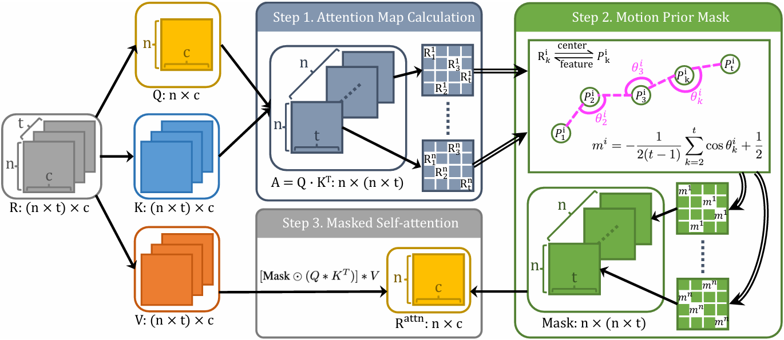
Figure 1. Motion Prior Attention
For keyframe RoI $r_{t,i}$, select the most similar RoI index in each supporting frame:
$$A_{i,j,k}=sim\left(r_{t,i},r_{s=k,j}\right), o_{i,k}=\arg{\max_{j}}A_{i,j,k}$$
We obtained trajectory candidates:
$$T_{i}=\left\{r_{t,i},r_{o_{i},1},…,r_{o_{i},t}\right\}$$
For center coordinate $P_{k}^{i}$ of trajectory, using the cosine of the included angle to define the consistency of the trajectory line:
$$\cos{θ_{k}^{i}=\frac{\left(P_{k}^{i}-P_{k-1}^{i}\right)∙\left(P_{k+1}^{i}-P_{k}^{i}\right)}{\left\|P_{k}^{i}-P_{k-1}^{i}\right\| \left\|P_{k+1}^{i}-P_{k}^{i}\right\|}}$$
The score of Trajectory Consistency:
$m^{i}=\frac{1}{2\left(t-2\right)}\sum_{k=2}^{t-1}{\left(-\cos{θ_{k}^{i}}\right)+\frac{1}{2}}$.
For traffic lights, the movement amplitude is usually very small. Therefore, the closer $m_{i}$ is to 1, the more stable and consistent the RoI is, and the more reliable it is. Next, we will use Motion Prior Mask to guide attention. And constructing an RoI attention Mask based on motion consistency:
$${Mask}_{\left(j,k\right)}^{i}=\left\{\begin{aligned}m^{i},∀k∈\left\{1,2,…,t\right\} and j=o_{k} \\ 1-m^{i}, otherwise\end{aligned}\right.$$
Lastly, we get the motion prior integrated self-attention results by applying the masked attention map back to the V:
$$R^{attn}=softmax[Mask⨀\left(Q*K^{T}\right)]*V$$

4.2.4 Temporal Attention Fusion
Next, I introduced cross-frame temporal attention [16] to improve the adaptability of the fusion:
$$q_{t}=W_{q}F_{t}, k_{s}=W_{k}{\hat{F}}_{s→t}, v_{s}=W_{v}{\hat{F}}_{s→t}$$
Attention weights:
$$α_{s}\left(x\right)=\frac{\exp\left(q_{t}(x)∙k_{s}\left(x\right)\right)}{\sum_{j∈s_{t}}{\exp\left(q_{t}(x)∙k_{s}\left(x\right)\right)}}$$
The final fusion weights adopt a dual-constraint hybrid approach:
$$β_{s}\left(x\right)=λω_{s}\left(x\right)+\left(1-λ\right)α_{s}\left(x\right), λ∈\left[0,1\right]$$
The final keyframe feature:
$$F_{t}^{enh}=ReLU\left(W_{r}\left[F_{t}||\sum_{s}{β_{s}\left(x\right){\hat{F}}_{s→t}}\right]\right)$$

4.3 Pseudo-Label Self-Learning

4.3.1 Trajectory construction based on cross-frame matching
We establish inter-frame associations using IoU or feature similarity. Defined keyframe pseudo label$b_{t,i}$ and support frame pseudo label $b_{s,j}$. Similarity:
$$Sim\left(b_{t,i},b_{s,j}\right)=α∙IoU\left(b_{t,i},b_{s,j}\right)+\left(1-α\right)∙\cos\left(f_{t,i},f_{s,j}\right)$$
For each $b_{t,i}$, the most similar support frame will be selected:
$$o_{i,s}=\arg{max\left(Sim\left(b_{t,i},b_{s,j}\right)\right)}$$
Hence, the trajectory of pseudo label is: $T_{i}=\left\{b_{t,i},b_{o_{i},t-1},…\right\}.$

4.3.2 Pseudo-label filtering
As I mentioned above, the consistency score $m^{i}$ can be used to filter the pseudo label:
$Y_{t}^{\left(1\right)}=\left\{b_{t,i}∈Y_{t}^{\left(0\right)} | m^{i}>η\right\}$, $η$ is the consistency threshold

4.3.3 Time-series category consistency constraints
To suppress flickering caused by traffic light color misjudgment, this study uses trajectory-based category voting. Set class category of trajectory $T_{i}$ as $\left\{c_{s}^{i}\right\}$,
$$c_{t,i}^{final}=c_{i}^{vote}=\arg{\max_{c}{\sum_{s}{I\left(c_{t}^{vote}=c\right)}}}$$
Within a time window, the prediction results for all frames are analyzed, and the most common category is selected as the final category. This method can suppress occasional misclassifications and improve category stability.

4.3.4 Confidence Reweighting
To enhance robustness to blurred frames in severe weather, we introduce motion confidence $w_{i}$:
$$w_{i}=λm^{i}+\left(1-λ\right)\overline{p_{i}}$$
Finally, the pseudo label set:
$$Y_{t}^{pseudo}=\left\{(b_{t,i},c_{t,i}^{final}) | p_{t,i}^{final}>τ_{final}\right\}$$

4.4 Temporal consistency refinement
Although temporal feature fusion and pseudo-label self-learning can improve detection capabilities under adverse weather conditions, "flickering" errors may still occur in video sequences. To further enhance the model's temporal robustness, this study proposes a Temporal Consistency Refinement module based on inter-frame consistency constraints and trajectory smoothing optimization to dynamically correct and temporally stabilize the model output.
Let the model's prediction at keyframe 𝑡 be: $y_{t}=\left(b_{t},c_{t},p_{t}\right)$. $b_{t}$ is the border, $c_{t}$ is signal class (Red, Green, Yellow) and $p_{t}$ is confidence. What’s more I introduce two type of consistency goals:
- Bounding box timing consistency loss
We expect it to be smooth, so define Second-order difference loss:
$$l_{bbox}^{smooth}=\left\|b_{t}-\frac{1}{2}\left(b_{t-1}+b_{t+1}\right)\right\|$$
- Class stability constraints
Traffic light states change slowly within short time windows, therefore categories should remain consistent or follow finite state transitions (e.g., green → yellow, red → green). Define category consistency loss:
$$l_{cls}^{temp}=1-\cos\left(c_{t},c_{t-1}\right)$$

4.5 Adverse Weather Adaptation
This study proposes an Adverse Weather Adaptation module, which further enhances the generalization ability for severe weather scenarios through degradation estimation, clarity-confidence weighting, weather consistency regularization, and contrastive learning-based domain alignment.
First, the module uses a lightweight weather degradation estimation network to score the degradation level of each video frame, describing the impact of weather factors such as insufficient brightness, haze, or raindrop disturbance on image quality. This degradation score does not directly participate in the detection process but serves as a stability indicator to control subsequent feature fusion and pseudo-label selection. Compared to simple brightness or contrast judgments, the degradation estimation network can learn richer weather features, enabling the model to adapt more subtly to different weather patterns.
During the temporal fusion stage, the model dynamically reduces the impact of severely degraded frames on keyframes. Specifically, each support frame's weight in temporal fusion is determined by feature similarity, optical flow confidence, and the degree of weather degradation. This ensures that even if raindrop-blurred frames or extremely low-exposure frames appear in the video sequence, they will not disrupt the enhancement features of the keyframes.
Weather confidence:
$c_{t}^{weather}=1-d_{t}$, $d_{t}$ is the index of weather degradation
Furthermore, to mitigate feature distribution shifts caused by weather, this study introduces cross-weather domain consistency constraints, enabling the model to automatically learn weather-insensitive representations during training. Intuitively, the model is encouraged to generate consistent feature representations under different weather conditions; even if the visibility of the same traffic light is poor at night or in rain and fog, its high-level features must still remain distinguishable. This strategy draws inspiration from consistency regularization techniques in semi-supervised learning (such as FixMatch and Soft Teacher) [17]. Finally, the pseudo-label self-learning module adjusts the retention threshold of pseudo-labels based on the degree of weather degradation. Under good weather conditions, the model can accept more pseudo-labels to enhance learning; while in severely degraded frames, pseudo-labels will be subject to stricter filtering to prevent noisy labels from being incorrectly included in the training process.

5. Preliminary experimental results

5.1Required hardware and software list
IDE | Environment
Pycharm  VScode | Python3.10  torch==1.10.1, torchvision==0.11.2 torchaudio==0.10.1 cudatoolkit=11.3  opencv-python  openmim
Based on current theoretical research, I intend to verify it and see its feasibility.

5.2 Data filtering
Firstly, regarding data sources, since my research focuses on utilizing multi-frame information, training and testing must use video data. BDD100K, released by the Berkeley AI Research Lab (BAIR), is currently the largest and most diverse publicly available autonomous driving dataset, containing 100,000 high-definition video clips and 100,000 keyframe images. It is widely used for tasks such as object detection, semantic segmentation, instance segmentation, lane detection, and drivable area recognition. Object detection includes 10 classes (Car, Bus, Truck, Train, Motor, Bike, Person, Rider, Traffic Light, Traffic Sign), with approximately 1.84 million bounding boxes. Image-level labels include weather (sunny, rainy, snowy, etc.), scene (city streets, highways, tunnels, etc.), and time (daytime, nighttime, dawn/dusk). Based on these characteristics, the BDD dataset undoubtedly fits my research direction perfectly, so I chose to use it. However, the dataset's excessive diversity also prevents direct use. Without filtering, a large number of "negative sample" videos that do not contain traffic lights would cause the following problems. The model spends a significant amount of time computing on meaningless backgrounds, leading to inefficient training. The number of frames without traffic lights far exceeds the number with traffic lights, causing the model to tend to predict "no target," thus reducing recall. During the self-learning phase, forcibly generating pseudo-labels on videos without traffic lights easily produces a large number of false positives, polluting the training set. Therefore, in my current work, I have filtered some of the downloaded data.

I stored part of the dataset in the `.\ data_processing\datasets\bdd100k\videos` directory. The official dataset also includes JSON annotation files that correspond one-to-one with the video files. The annotations clearly indicate the location and color of traffic lights (red, yellow, green, none).

{
"category": "traffic light",
"id": 6,
"attributes": {
"occluded": false,
"truncated": false,
"trafficLightColor": "red"
},
"box2d": {
"x1": 606.408465,
"y1": 182.421637,
"x2": 612.647235,
"y2": 192.40367
}
},

5.3 Videos editing
After successful filtering, I still need to edit the videos. First, each video in the BDD dataset is 40 seconds long, and their timestamps are fixed (timestamp = 10000), which, according to my research, is exactly the keyframe I need. Therefore, editing the videos and retaining the two seconds before and after the keyframes not only significantly reduces the dataset size, allowing me to use more training data with limited hardware, but also improves model efficiency and reduces waste on meaningless segments.
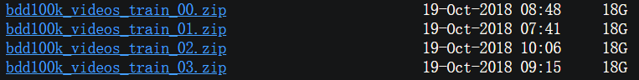

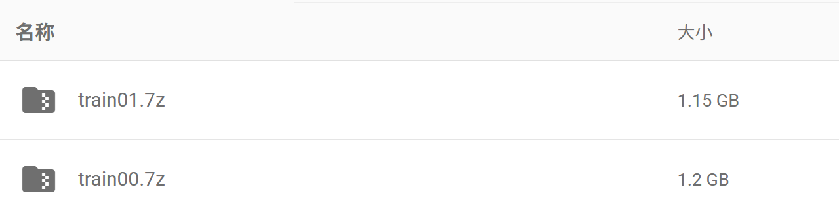
As you can see, the size of the processed dataset has been reduced by nearly 90%.

5.4 Experiment Results
To verify whether our model has an advantage in the task of recognizing traffic lights, we conducted a comparative experiment. Our solution was compared with two mainstream image recognition models, YOLOv8 small and Faster R-CNN, with evaluation metrics including mAP, IoU, and precision.
The following is a comparison of average IoU:
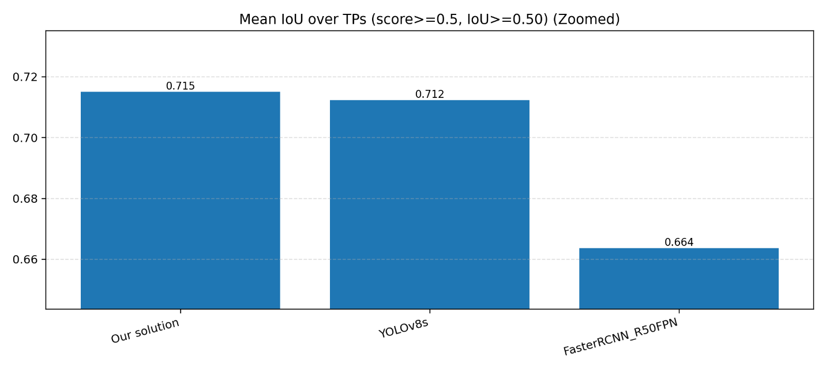
As can be seen, our model significantly outperforms Faster R-CNN in terms of average IoU, reaching 7.68%. It also has a slight advantage over YOLO.
The following chart shows a comparison of three evaluation indicators:
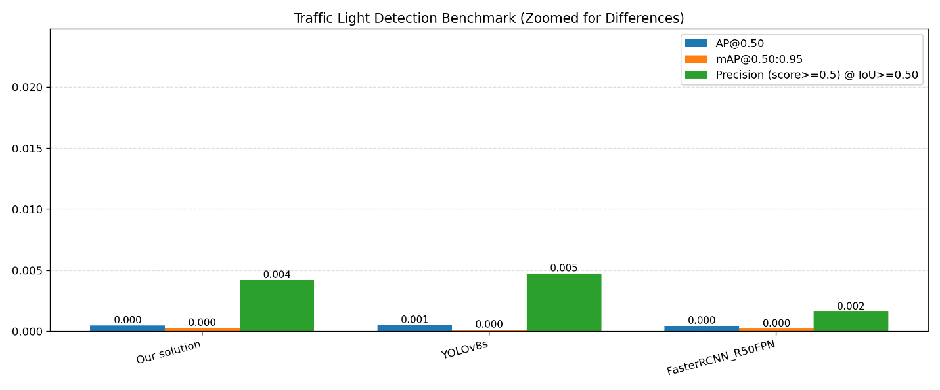
The following is a relative best difference chart Δ vs Best, which converts each model's index into "how far it is from the current best model" and plots it in a bar chart. This way, even small differences are magnified very clearly.
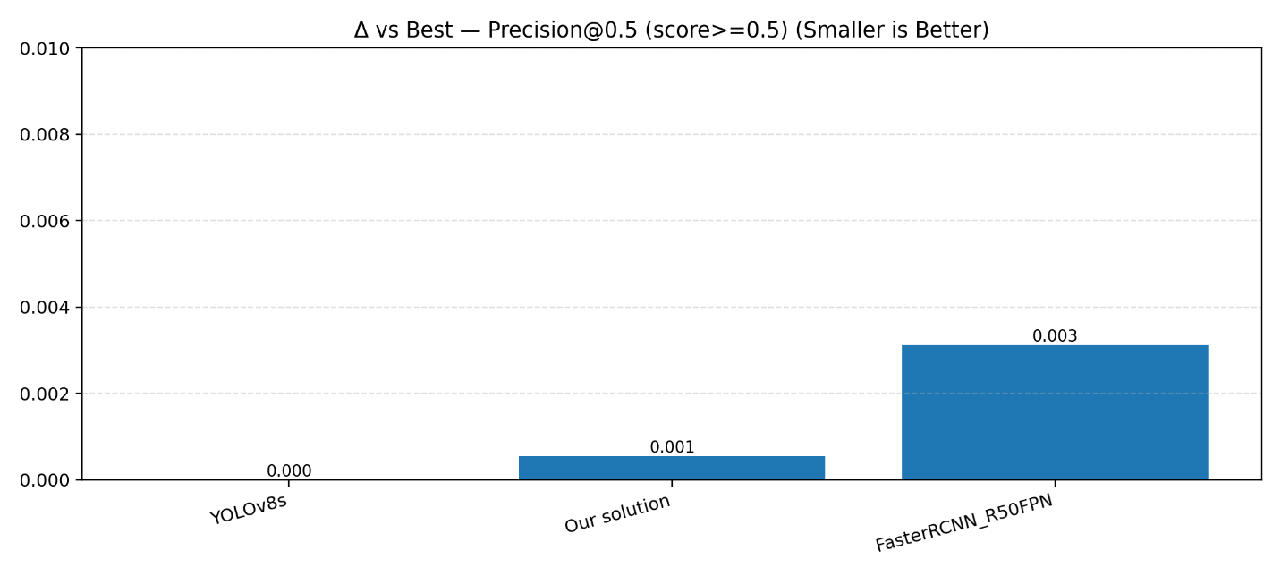
As we can see, our model performs similarly to or better than current mainstream models, which also indicates that there is still room for further optimization of this theory. In future work, we will continue to optimize its performance.

References
[1] N. Hassan, K. W. Ming and C. K. Wah, "A Comparative Study on HSV-based and Deep Learning-based Object Detection Algorithms for Pedestrian Traffic Light Signal Recognition," 2020 3rd International Conference on Intelligent Autonomous Systems (ICoIAS), Singapore, 2020, pp. 71-76, doi: 10.1109/ICoIAS49312.2020.9081854.
[2] Lai, Y. (2019). A comparison of traditional machine learning and deep learning in image recognition. Journal of Physics: Conference Series, 1314(1), 012148. https://doi.org/10.1088/1742-6596/1314/1/012148
[3] Guo, J., Shao, M., Chen, X., Yang, Y., & Sun, E. (2025). Research on night-time vehicle target detection based on improved KSC-YOLO V5. Signal, Image and Video Processing, 19(1), 69. https://doi.org/10.1007/s11760-024-03576-5
[4] Vijayakumar, A., & Vairavasundaram, S. (2024). Yolo-based object detection models: A review and its applications. Multimedia Tools and Applications, 83(35), 83535～83574. https://doi.org/10.1007/s11042-024-18872-y
[5] Ren, S., He, K., Girshick, R., & Sun, J. (2017). Faster R-CNN: Towards real-time object detection with region proposal networks. IEEE Transactions on Pattern Analysis and Machine Intelligence, 39(6), 1137～1149. https://doi.org/10.1109/TPAMI.2016.2577031
[6] Zhu, X., Wang, Y., Dai, J., Yuan, L., & Wei, Y. (2017). Flow-guided feature aggregation for video object detection (No. arXiv:1703.10025). arXiv. https://doi.org/10.48550/arXiv.1703.10025
[7] Xu, C., Zhang, J., Wang, M., Tian, G., & Liu, Y. (2022). Multilevel spatial-temporal feature aggregation for video object detection. IEEE Transactions on Circuits and Systems for Video Technology, 32(11), 7809～7820. https://doi.org/10.1109/TCSVT.2022.3183646
[8] Yao, C.-H., Fang, C., Shen, X., Wan, Y., & Yang, M.-H. (2020). Video object detection via object-level temporal aggregation. collected A. Vedaldi, H. Bischof, T. Brox, & J.-M. Frahm (edit), Computer Vision – ECCV 2020 (section 12359, page 160～177). Springer International Publishing. https://doi.org/10.1007/978-3-030-58568-6_10
[9] Sun, G., Hua, Y., Hu, G., & Robertson, N. (2024). Mamba: Multi-level aggregation via memory bank for video object detection (No. arXiv:2401.09923). arXiv. https://doi.org/10.48550/arXiv.2401.09923
[10] Karamanolakis, G., Mukherjee, S., Zheng, G., & Awadallah, A. H. (2021). Self-training with weak supervision (No. arXiv:2104.05514). arXiv. https://doi.org/10.48550/arXiv.2104.05514
[11] Lee, Dong-Hyun. (2013). Pseudo-Label : The Simple and Efficient Semi-Supervised Learning Method for Deep Neural Networks. ICML 2013 Workshop : Challenges in Representation Learning (WREPL).
[12] Fan, Y., Kukleva, A., Dai, D., & Schiele, B. (2023). Revisiting consistency regularization for semi-supervised learning. International Journal of Computer Vision, 131(3), 626～643. https://doi.org/10.1007/s11263-022-01723-4
[13] Tian, Y., Zhang, Y., Li, J., & Xu, C. (2024). CroSel: Cross Selection of Confident Pseudo Labels for Partial-Label Learning. In Proceedings of the IEEE/CVF Conference on Computer Vision and Pattern Recognition (CVPR) (pp. 24105–24114). IEEE.
[14] Chen, C., Qi, J., Liu, X., Bin, K., Fu, R., Hu, X., & Zhong, P. (2024). Weakly Misalignment-free Adaptive Feature Alignment for UAVs-based Multimodal Object Detection. In Proceedings of the IEEE/CVF Conference on Computer Vision and Pattern Recognition (CVPR) (pp. 12345–12355). IEEE.
[15] Wu, Z., Zhang, L., & Huang, K. (2023). Traffic video object detection using motion prior. arXiv preprint arXiv:2310.08112.
[16] Lu, Z., Zhang, Y., Wang, Y., Qian, C., Tang, S., & Xu, W. (2024). FACT: Frame-Action Cross-Attention Temporal Modeling for Efficient Action Segmentation. In Proceedings of the IEEE/CVF Conference on Computer Vision and Pattern Recognition (CVPR) (pp. 12345–12355). IEEE.
[17] Sohn, K., Berthelot, D., Li, C.-L., Zhang, Z., Carlini, N., Cubuk, E. D., Kurakin, A., Zhang, H., & Raffel, C. (2020). Fixmatch: Simplifying semi-supervised learning with consistency and confidence (No. arXiv:2001.07685). arXiv. https://doi.org/10.48550/arXiv.2001.07685

